Assignment 7

210010033

Om Deshmukh

Part 1:

For first one where we execute

%traceroute gaia.cs.umass.edu 2000

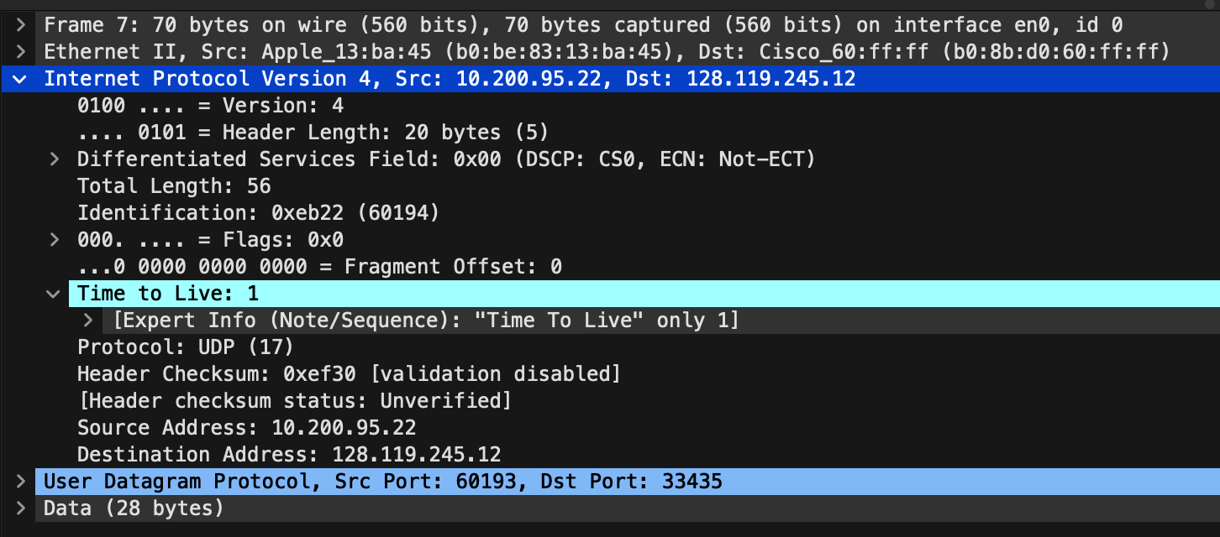

1. The ip address of my computer is 10.200.95.22
2. The TTL value for the first UDP packet sent is 1.
3. UDP is the upper layer protocol here in this case.
4. The size of the IP header is 20 bytes.
5. The total length is 56 bytes
6. Since the fragmented offset is 0, we can guarantee that the ip datagram has not been fragmented.  
     
     
     
     
     
   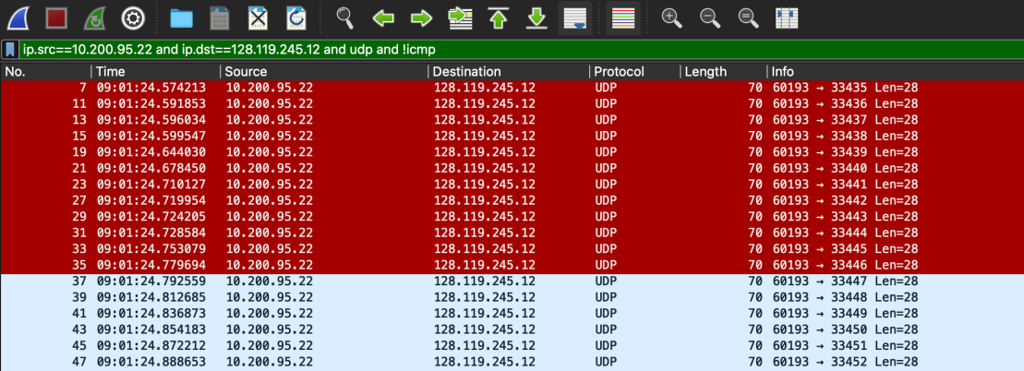
7. TTL, Identification and Header Checksum are the fields which change from one datagram to another
8. The fields that remain constant include
   1. Version (since we are using IPv4 for all packets)
   2. Header length (since these are ICMP packets)
   3. Source IP (since we are sending from the same source)
   4. Destination IP (since we are sending to the same destination)
   5. Differentiated Services (since all packets are ICMP they use the same Type of Service class)
   6. Upper Layer Protocol (since these are ICMP packets)
9. The identification values in the consecutive IP datagrams changes by 1 hex unit.
10. ICMP is the upper layer protocol specified in the IP datagrams returned from the routers.
11. No, the changes in values in the identification field is completely different than the case in question 9. Here, in this case it is changing randomly.
12. Yes, the TTL values are nearly similar for the consecutive IP datagrams. However, in some cases they differ as well.

Part 2:

1. Yes, the IP datagrams have been fragmented. .
2. 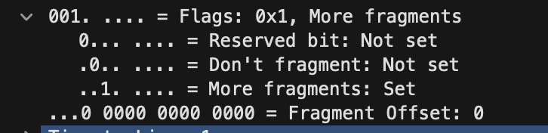  
   We can be sure since MORE FRAGMENTS bit is Set
3. Fragment offset is 0 for the first fragment whereas its non zero for other fragments.
4. The total size of the datagram(header + payload) is 1500 bytes.
5. Fragment offset and Checksum change between the first and second fragments.
6. 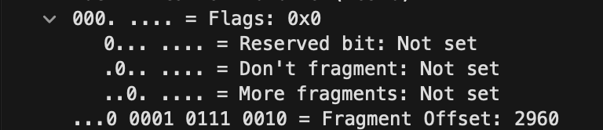  
     
   Packet number 17 here is the IP datagram containing the third fragment of the original UDP segment. The fact that MORE FRAGMENTS have not been set represents that this is the last fragment of the segment.

Part 3:

1. Source Address of computer making the DNS query is 2601:193:8302:4620:215c:f5ae:8b40:a27a
2. Destination Address is 2001:558:feed::1
3. Flow Label value of this datagram is 0x63ed0
4. 37 bytes
5. UDP protocol is the upper layer protocol of this datagram
6. Only 1 IPV6 address is returned in response.
7. Address returned is 2607:f8b0:4006:815::200e